**Project Design Phase-II**

**Data Flow Diagram & User Stories**

|  |  |
| --- | --- |
| Date | 10 October 2022 |
| Team ID | PNT2022TMID44103 |
| Project Name | Real-Time Communication System Powered by AI for Specially Abled |
| Maximum Marks | 4 Marks |

**Data Flow Diagrams:**

A Data Flow Diagram (DFD) is a traditional visual representation of the information flows within a system. A neat and clear DFD can depict the right amount of the system requirement graphically. It shows how data enters and leaves the system, what changes the information, and where data is stored.

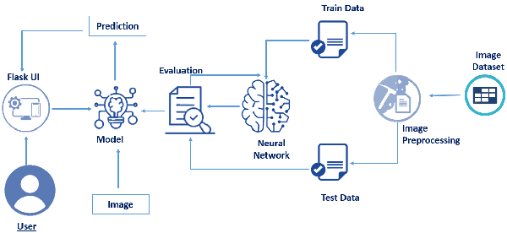

**User Stories**

Use the below template to list all the user stories for the product.

| **User Type** | **Functional Requirement (Epic)** | **User Story Number** | **User Story / Task** | **Acceptance criteria** | **Priority** | **Release** |
| --- | --- | --- | --- | --- | --- | --- |
| Customer (Mobile user) | Registration | USN-1 | As a user, I can register for the application by entering my email, password, and confirming my password. | I can access my account / dashboard | High | Sprint-1 |
|  |  | USN-2 | As a user, I will receive confirmation email once I have registered for the application | I can receive confirmation email & click confirm | High | Sprint-1 |
|  |  | USN-3 | As a user, I can register for the application through Facebook | I can register & access the dashboard with Facebook Login | Low | Sprint-2 |
|  |  | USN-4 | As a user, I can register for the application through Gmail | I can access my account  / dashboard | Medium | Sprint-1 |
|  | Login | USN-5 | As a user, I can log into the application by entering email & password | I can access my  dashboard | High | Sprint-1 |
|  | Dashboard | USN-6 | As a user, I can capture the image of the  fruit use capture option | Through which I can get  the nutrition present in  the fruit | High |  |
| Customer (Web user) |  | USN-7 | As a user, I can register for the application  by entering my email, password, and  confirming my password. | I can access my account  / dashboard | High |  |
| Customer Care Executive |  | USN-8 | As a customer care executive I can resolve  the login issues or any issue of the  customer | I can provide support for  24X7. | medium |  |
| Administrator | Application | USN-9 | As an administrator I can update the  application | I can resolve the bugs  which arises for the users  of the app | medium |  |